Contents
Preface v
Before You Begin vii
Unpacking vii
System Requirements vii
Licensed Copies vii
Installation and Starting Up vii
Assistance viii
About the Program 1
Introduction 1
Graphs & Tracks Part I—From Graphs to Motion 1
Getting Started 1
Exercises: From Graphs to Motion 2
Choose an Example 2
Choose a Graph Type 3
Roll the Ball and Observe the Motion 4
Set the Starting Position of the Ball 4
Set the Starting Speed and Direction 4
Adjust the Tracks 5
Clear Cluttered Graphs 5
Help: Graphs & Tracks i 5
Graphs & Tracks Part ii—From Motion to Graphs 6
Getting Started 6
Create a Segment 6
Edit a Segment 7
Delete a Segment 8
Clip or Restore a Curved Segment 9
Get Feedback 9
Exercises: From Motion to Graphs 10
Help: Graphs & Tracks II 10
Appendix A: Notes to the Teacher 13
Suggested Usage 13
Research Basis 13
How the Help Facilities Work 13
Simplifying Assumptions 14
References 15
Appendix B: Technical Information 17
PC Memory Note 17
Manual Installation of PC Files 17
GRAPHS & TRACKS PC Files 17
Physics Academic Software PC Files 18
GRAPHS & TRACKS Macintosh Files 19
Physics Academic Software Macintosh Files 19
cT Information 19
Appendix C 21
Exercise Set I: GRAPHS & TRACKS 21
Questions 22
Student Worksheet for Graphs and Tracks 23
About Physics Academic Software 25
Multiple-Copy License Order Form 27
Index 29

Preface
Wouldn’t it be nice if learning physics were like playing a game? GRAPHS & TRACKS is a goal-oriented program that makes learning about graphs of motion a playful activity. You learn about graphs of position, velocity, and acceleration, and explore the connection between animated motions and graphs.
The Graphs & Tracks Program
This software package simulates a ball rolling on inclined tracks. You set up motions by adjusting the tracks and positioning the ball, and you sketch graphs of motions by using a graph drawing editor. GRAPHS & TRACKS contains a collection of instructive examples that are organized from simple to difficult. You can make up your own problems and either solve them yourself or challenge your friends to do so. There are interactive instructions on using the programs, and on-line help about graphs and motion is always available.
GRAPHS & TRACKS is based upon research and curriculum development by the Physics Education Group at the University of Washington. The preliminary design originated at the Educational Technology Center at the University of California, Irvine, and a prototype was developed by Wilfred J. Hansen from the Information Technology Center, Carnegie Mellon University. A drawing editor, draw.t, was written by Bruce Sherwood at Carnegie Mellon University.
GRAPHS & TRACKS is written in the cT programming language developed in the Center for Design of Educational Computing (CDEC) at Carnegie Mellon University.

Before You Begin

Unpacking
Your package for GRAPHS & TRACKS contains the following:

- The User’s Manual (this book)
- One set of diskettes labeled Original Copy
- One set of labels imprinted Archival Copy for your backup copy
- One registration card

The User’s Manual contains information on how to operate the program and how to execute the commands. It also contains student worksheets along with teaching suggestions.

System Requirements
The PC version requires a PC computer.

- The Macintosh version requires a Macintosh computer with Classic OS available.

Licensed Copies
As a registered owner of a single-copy license, you may copy the program onto your hard disk; however, you may not use this program on more than one hard disk at a time.
You may obtain a multiple-copy license from Physics Academic Software. Each multiple-copy license authorizes you to use up to ten copies of the program. An order form for the license is in the back of this manual.
Each authorized copy may be loaded onto one hard-disk system. The program may be loaded on a network computer system, but one authorized copy is required for each computer operating the program simultaneously.

Installation and Starting Up
To install the PC version of GRAPHS & TRACKS,

- Insert the GRAPHS & TRACKS diskette into drive a
- Type a:install and press Enter
- Follow the instructions on the screen

Two directories, CT201 and GRPHTRCK, will be installed on your c: root directory unless you specify another drive and/or directory.
To start the PC version of GRAPHS & TRACKS,

- Load the mouse driver for your mouse if it is not already loaded
- Type cd c:\GRPHTRCK and press Enter
- Type start and press Enter

Substitute your drive or directory in step 2 if appropriate.
The program will display the title of the program and the name of the author and will allow you to view or print GRAPHS & TRACKS I or GRAPHS & TRACKS II. Follow the instructions on the screen or refer to Appendix B for additional help.
To install the Macintosh version of GRAPHS & TRACKS,

- Insert the GRAPHS & TRACKS diskette into the disk drive
- Double-click the file labeled GRAPHS & TRACKS Installer
- When the directory dialog box appears, select a location on your hard disk and click the Save button

The installer will put the GRAPHS & TRACKS folder on your hard disk.
To start the Macintosh version of GRAPHS & TRACKS,

- Double-click the folder labeled GRAPHS & TRACKS
- When the directory window opens, double-click the icon labeled GRAPHS & TRACKS I or GRAPHS & TRACKS II

The program will display the title of the program and the name of the author.

- Follow the instructions on the screen to proceed

Assistance
Physics Academic Software is committed to providing prompt and courteous technical support. If you cannot find the answer to your problem in the User’s Manual, our technical support staff is glad to assist you.
Describe your question or problem in detail. If you have a problem with the software, report what you did (the steps or procedures you followed) leading up to the problem. Also report your hardware configuration and the exact error message, if one appeared.
Send your question or problem to one of the following:

pas@aip.org
E-mail:

(919) 829-1516
Fax:

Physics Academic Software
Mail:
940 Main Campus Drive
Suite 210
Raleigh, NC 27606

About the Program

Introduction
GRAPHS & TRACKS consists of two parts. In Part I—From Graphs to Motion, you look at graphs of position, velocity, and acceleration versus time for given examples of one-dimensional motion. You then try to set up an arrangement of sloping tracks so that a ball rolling on the tracks will reproduce the motion shown in the graphs. On-line help is available.
Part II—From Motion to Graphs reverses this concept: you watch a ball rolling on a set of tracks, read a description of its motion, and then try to sketch the graphs that describe that motion. You don’t need to make your graphs exact; the program simply looks for the most important features and evaluates them with a tolerance for error. You may request feedback on your graphs at any time.

Graphs & Tracks Part I—From Graphs to Motion

Getting Started
Install and start up GRAPHS & TRACKS I according to the instructions on pages viii–ix.
The title page for Part I—From Graphs to Motion will appear. To display a screen of credits and get information regarding the development of the program, select About Graphs and Tracks... from the Option menu.
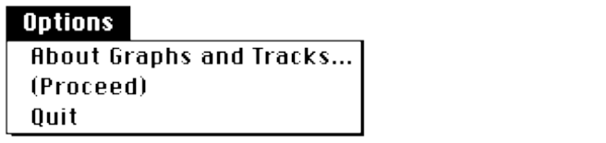
GRAPHS & TRACKS assumes you are familiar with mouse terminology basics. If you are not, see the Terminology section on page viii.
To run a short tutorial on GRAPHS & TRACKS,
Click the button labeled “Your first time? Click here for instructions”.
This section will walk you step by step through the various features of the program and then take you into the main program itself.
To skip the walk-through section, click the bottom button labeled “You’ve used this program before? Click here”.
Once inside the program, you may return to the instructions by selecting Instructions from the Options menu.
At each step, find the flashing box and follow the instructions in the upper left corner of the screen. Try out each feature of the program as it is presented. After completing the instructions, you will be able to do things in any order. You may quit the instructions at any time by selecting Skip instructions from the Options menu.

Exercises: From Graphs to Motion

Choose an Example
GRAPHS & TRACKS I includes eight built-in examples of motion: the first four are fairly simple, and the next four are slightly more complex. To select another example, use the Examples menu:
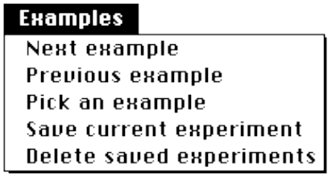
Next example will increment the example number up to the current maximum, then roll over to 1; similarly, Previous example will decrement the number to 1, then roll over to the current maximum. Pick an example will prompt you to type an example number and press E.
In addition to the eight given examples, you may add up to 20 new examples. Use the Free exploration option on the Options menu to suppress plotting of the given graphs if you like. To add an example, set up an arrangement of ramps with the initial conditions you want. Then select Save current experiment from the Examples menu. Your example will be numbered sequentially and stored in a file named gt.dat.
You can then access this “Custom” example as a problem by selecting Pick an example from the Examples menu and entering the corresponding number.
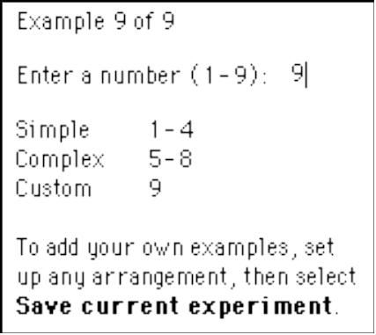
Examples created using Part I are read in by Part II as well. All on-line help works the same for Custom examples as for built-in (Simple or Complex) examples.
Delete saved experiments will delete the file gt.dat, discarding the Custom examples, but will leave the built-in examples intact.

Choose a Graph Type
A graph of position vs. time is shown for each example. The example or “goal” graphs always appear using dotted lines.
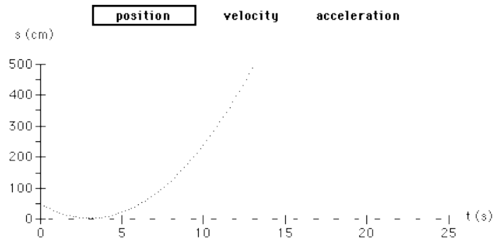
You may view each example of motion in terms of its position, velocity, or acceleration graph. To switch among graph types, simply click the graph title of your choice. Of course, each graph represents the motion in a different way, and each has its own advantages and disadvantages. After experimenting with the program, you should be able to determine which kind of graph is most useful for obtaining what kind of information.
The ball rolls according to the arrangement of the tracks you see. As it rolls, a solid curve is drawn.
If you prefer, you can select Dashed curve from the Graph menu. This will enable you to compare two trials more easily, because dashed curves are drawn somewhat faster than solid curves.

Roll the Ball and Observe the Motion
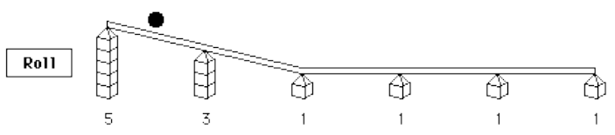
To roll the ball, click the Roll button, or select Roll ball from the Graph menu.
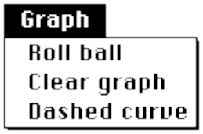
A solid curve corresponding to the actual motion is plotted on the graph.
While the ball is rolling, a Stop button appears. Click this button if you want to terminate the animation.
You may view the motion in short segments on the Macintosh by holding down s when you click the Roll button. To do this on the PC, click the Roll button with the right mouse button. This causes the ball to roll along the ramp until it reaches the next bend in the tracks (a junction where the slope changes). The ball pauses there until you click again. This feature makes it a little easier to see the correspondence between a segment of the motion and a section of the graph.

Set the Starting Position of the Ball
Use the mouse to set the initial position. You may either drag the marker icon to a new location, or simply click the desired value. The origin (zero) of the position scale is located at the left-most post. Position values, measured in centimeters, increase toward the right, up to 500 cm at the right-most post. Values you select are rounded to the nearest 50 cm.

Set the Starting Speed and Direction
Use the mouse to set the initial velocity. Positive numbers (to the right of zero) indicate initial velocities toward the right; negative numbers (to the left of zero) indicate velocities toward the left. Click the desired value or drag the marker to an initial velocity value of your choice. Values are rounded to the nearest 10 cm/s.

Adjust the Tracks
To adjust the tracks, move the mouse pointer near a junction at the top of a post.
Make sure that the tip of the pointer is touching the tracks directly above a junction.
Press and hold down the mouse button. Slide the mouse up or down to raise or lower the junction.
Note that post heights are displayed as numbers of blocks; as you drag the junction, adjoining tracks will snap to the next higher or lower block position.
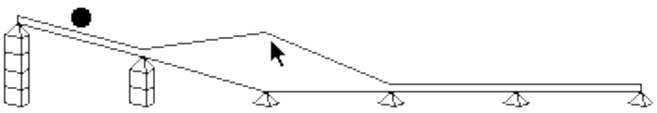
You may adjust the initial conditions or post heights, roll the ball, or change graph types in any order you like.

Clear Cluttered Graphs
To clear the graphs, click anywhere on the graph or select Clear graph from the Graph menu.
Selecting Free exploration from the Options menu enables you to practice adjusting the track’s arrangement and to study the graphs generated by motions of the rolling ball. In the Free exploration mode, no goal graphs are presented, and there is no particular problem to solve.
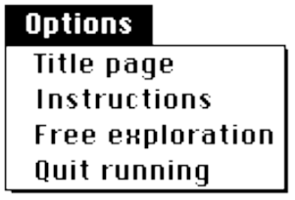
When you are ready to return to the exercises, select Problem examples from the Options menu.

Help: Graphs & Tracks i
A help facility is available from the Help menu. By comparing your current graph with the goal graph, Help gives you suggestions for making your graph closer to the goal. These are only suggestions; you may make any adjustments you like. The Give help once option provides only one suggestion; Leave help on gives you continuous suggestions as you make changes in your apparatus. To turn off the help, select Hide help.
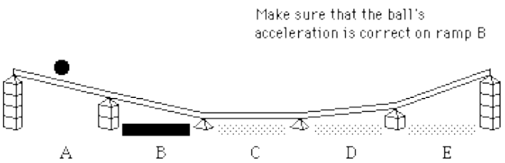
In addition to providing written help, the help facility highlights those aspects of your arrangement that need attention. Shaded bars beneath the tracks indicate incorrect inclinations; shaded labels of Initial position and Initial velocity indicate problems with your initial conditions. Solid black highlighting corresponds to the aspect currently referred to in the verbal suggestion; gray highlighting indicates problems with other parts of the arrangement.

Graphs & Tracks Part ii—From Motion to Graphs

Getting Started
Install and start up GRAPHS & TRACKS II according to the instructions on page viii–ix.
If this is your first time using Part II, click the circle labeled “Your first time? Click here for instructions”.
Interactive instructions on how to use the program appear. You may request instructions on as many or as few features as you like, and in any order. As you read the instructions about each facility of the graph-drawing editor, feel free to try it out and experiment with it as much as you like. You may skip the instructions by selecting Skip instructions from the Options menu.

Create a Segment
A palette of shapes for drawing graphs is provided from which to choose segments for your graphs.
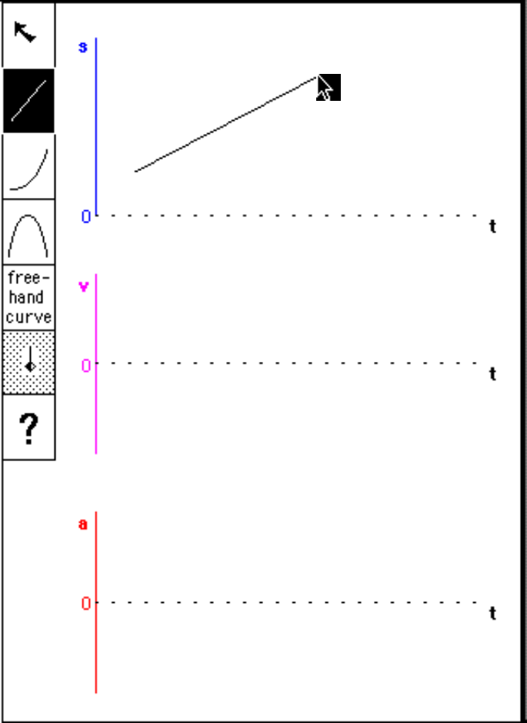
To create a segment,

- Click the shape of your choice and release the mouse button.
- Move the mouse arrow into the drawing region on the right.
- Press and hold down the mouse button as you drag the mouse, and then release

Try this for each of the drawing icons.

Edit a Segment
Graphing segments can only be altered when they have been selected. Selected segments appear with small black squares, or “editing handles.” If no shape is highlighted with handles, clicking near the shape you want to change will highlight it.
You can move segments without changing their size or shape by dragging the large handle at the center. Size and shape can be adjusted by dragging the smaller handles surrounding the segment.
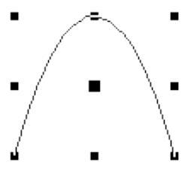
The option labeled “free-hand curve” allows you to sketch a curved section by hand. When you release the mouse button, a parabolic segment appears approximating the positions and slopes of your hand-drawn curve. Note that the free-hand option is only for single, parabolic segments; it is not designed for drawing straight segments or a series of segments. The program waits until you press a key before removing your free-hand curve to enable you to compare it with the smooth curve segment. The new segment can be edited just like the curved segments created with the half-parabola or parabola drawing icons.
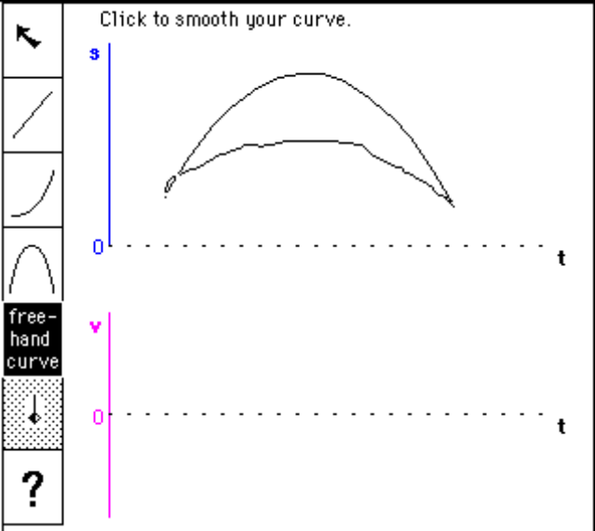

Delete a Segment
A selected segment can be deleted by simply pressing d or b, or by using the Delete menu.
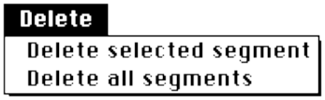
To delete all segments, select Delete all segments.
The program requests a confirmation before removing all segments. Type y to confirm your intentions, or press any other key to cancel the selection

Clip or Restore a Curved Segment
Occasionally, you need to join a curved segment with another straight or curved segment to match slopes at the endpoints. The Clip icon allows you to do this.
First select the curved segment you want to cut then click the Clip/Restore icon. Your cursor becomes a Clip tool.
Click and drag from a point beyond the curve to a point within the curve. Release the button. This clips away the selected section of the curve.
To restore a clipped piece of curve, click the Clip icon.
Click and drag from a point within the curve to a point beyond it. To restore an entire curve, select Restore parabola from the Clip menu.

Get Feedback
You may request feedback on your graphs at any time by clicking the question-mark icon,

The program will attempt to analyze your graphs in terms of the animations you observe and, if there is anything wrong with them, to give you some indication about how to correct them.
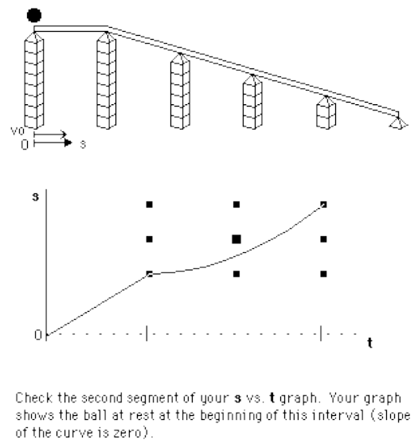
The feedback does not attempt to give a tutorial on the concepts of position, velocity, and acceleration, their interrelationships, or their graphical representations. It merely points to discrepancies between gross features of your graphs and graphs that would actually describe the motions shown.
You may draw position (s vs. t), velocity (v vs. t) or acceleration (a vs. t) graphs in any order. However, you must make sure that corresponding segments line up, one above the other, according to the time scales shown.
It is not necessary to show relative sizes of time intervals or ordinate values (position, velocity, acceleration), or changes in these quantities. The program ignores these comparisons and only checks for correct graph segment types, correct signs, and correct slopes. Position vs. time graphs are also checked for kinks that exceed some small change in angle.

Exercises: From Motion to Graphs
There are eight built-in examples to choose from in GRAPHS & TRACKS Part II. You may move from one to another using Next example, Previous example, and Pick an example options from the Examples menu. First view the animation. Do this by clicking the Roll button. After the ball rolls, a written description of the motion is displayed at the bottom. This description, generated automatically during the motion, will give you some extra help in understanding what you are seeing. While the animation is not perfectly smooth, it gives you a rough idea of the motion being discussed. If you are uncertain about the animation, use the verbal description as a guide. You can repeat the animation as many times as you like. If you want to see the motion one segment at a time, hold down s and click the Roll button on the Macintosh or click with the right mouse button on the PC.
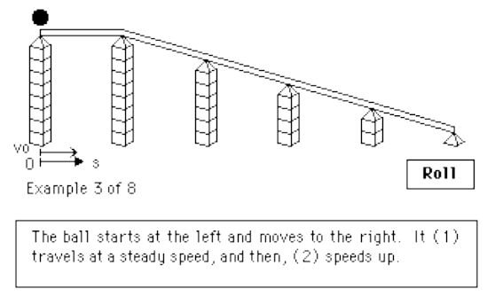

Help: Graphs & Tracks II
As you sketch graphs of position, velocity, and acceleration vs. time for each example of motion, you can request feedback at any time by clicking the question mark icon. The program analyzes the curves you have drawn and points out features that could be improved. The feedback message usually indicates what kind of motion a particular incorrect segment would represent and asks you to look again at the corresponding motion.

Appendix A: Notes to the Teacher

Suggested Usage
GRAPHS & TRACKS has been used in laboratory-based introductory physics courses as part of a range of learning activities on kinematics. These activities include experiments with actual steel balls that roll along aluminum U-channels, in which students use clocks and meter sticks to make measurements of clock readings, time intervals, positions and displacements. They perform pencil-and-paper exercises about the concepts of velocity, instantaneous velocity, and acceleration and their graphical representation.
GRAPHS & TRACKS serves as an ideal complement to activities involving a microcomputer-based motion detector. With this device, students can generate motion graphs by moving their own bodies forward and back in front of the detector.
Some students like to work with the GRAPHS & TRACKS program independently. Others enjoy working in pairs. For some, the competitive aspect is a powerful motivator: they like to make up their own problems and challenge their partners.

Research Basis
GRAPHS & TRACKS is an example of research-based software. The program was produced by incorporating results of research in physics education; in particular, work conducted by the Physics Education Group at the University of Washington.^{1,2} The topic of graphs of motion is central to the subject of one-dimensional kinematics, which is often the starting point for first-year introductory physics courses. However, the initial treatment of this subject is often too brief, and many students cannot apply the concepts of position, velocity, and acceleration to real motions.
A paper presented in The Proceedings of the Conference on Computers in Physics Instruction³ describes how research findings regarding student difficulties with graphs have been used to guide development of GRAPHS & TRACKS.

How the Help Facilities Work
In Part I—From Graphs to Motion, the program keeps track of the set of eight numbers (six post heights, an initial position value, and an initial velocity value) representing the goal graph, with the corresponding eight numbers of the student’s arrangement of tracks. When the student requests help, the program checks to see whether the student’s initial conditions are correct and whether the slopes on the student’s ramps match the ramps on which the ball would roll to produce the goal graph. Then the program highlights and comments on any discrepancies.
In Part II—From Motion to Graphs, the program must keep track of the number of segments in each set of axes, the time sequence, starting and ending times, initial and final slopes, and the type of each graph segment drawn. It compares these attributes with those corresponding to the animated motion. It also checks the continuity of values in s vs. t and v vs. t graphs, and the continuity of slope in s vs. t graphs).

Simplifying Assumptions
GRAPHS & TRACKS uses a number of simplifying assumptions to help students focus on the most important aspects of one-dimensional kinematics without getting lost in some of the complexities of real motions. These assumptions and idealizations are described below:

- To help students make adjustments to their arrangements of sloping tracks, the ramps are displayed with an exaggerated vertical dimension. Thus, the ramps are shown with slopes from 0–50° from the horizontal when they represent slopes of 0–5.7°. This small-angle approximation affects acceleration values by, at most, 0.5%. The examples in GRAPHS & TRACKS are treated as purely one-dimensional problems. The coordinate s is measured horizontally along the floor. Each segment of track should be thought of as having a fixed length of 100 cm.
- While the program refers to a “rolling” ball, in fact, acceleration values have been computed for sliding point masses, not rolling spheres. Treatment of solid spheres, rolling without slipping, would reduce all acceleration values by 29%.
- While actual balls would bounce at the sharp junctions shown in the simulation, the program constrains them to remain on the ramps at all times. No account is made for the x-component of impulses that would be delivered to the ball if it were crossing junctions to steeply sloping ramps. You can think of the junctions as being smooth and rounded so that the ball never “collides” with the tracks.
- The ball and track system is represented entirely without friction.
- The values of t shown on the time axis do not represent real time.

References
- L.C. McDermott, M. Rosenquist, and E.H. van Zee, “Student difficulties in connecting graphs and physics: Examples from kinematics, American Journal of Physics 55, 6 (1987).
- E.H. van Zee and L.C. McDermott, “Investigation of student difficulties with graphical representations in physics,” Proceedings of the Second International Seminar on Misconceptions and Educational Strategies in Science and Mathematics (Cornell University, NY, 1987).
- David Trowbridge, “Applying research results to the development of computer based learning materials,” Proceedings of The Conference on Computers in Physics Instruction held at North Carolina State University, Raleigh, NC (Addison-Wesley, NY, 1989).

Appendix B: Technical Information

PC Memory Note
If the program does not run successfully, there may be a conflict in the usage of extended or expanded memory (XMS and EMS). If this is the case, make XMSEMS.OFF the CT.PRF file. To do this from the CT201 directory,

- Type ren ct.prf ct.old
- Type ren xmsems.off ct.prf

This turns off GRAPHS & TRACKS’ use of XMS and EMS.

Manual Installation of PC Files
The usual way to install the PC version of GRAPHS & TRACKS is to use INSTALL.COM, which is an automatic installation program. If you would like to install the files manually, you can. The file EXTRACT.EXE is a self-extracting archive prepared by the program PKZIP (PKWARE, Inc.). When you run it, it will decompress onto the drive and into the directory you specify. To install GRAPHS & TRACKS manually,

- Place the GRAPHS & TRACKS diskette in drive a:
- Type a:extract -d c:\ to install the program onto the root directory of c: drive.

Note: the -d option is necessary to preserve the directory structure of the archive.

GRAPHS & TRACKS PC Files
This program will not run on an earlier version of the cT Executor, called CTEXEC.EXE, and earlier programs will not run with the cT 2.01 Executor, called CTX.EXE.

Batch file that runs the GRAPHS & TRACKS I program.
GT1.BAT

The compiled version of the GRAPHS & TRACKS I program written in the cT language.
GT1.CTB

Batch file that runs the GRAPHS & TRACKS II program.
GT2.BAT

The compiled version of the GRAPHS & TRACKS II program written in the cT language.
GT2.CTB

Font and graphics files used by CTX.EXE.
*.FPC

cT preference file that specifies the use of extra memory.
CT.PRF
File written when user saves current experiment.

File written when user saves current experiment.
GT.DAT

Copy to CT.PRF to turn off use of extra memory (see PC Memory Note section).
XMSEMS.OFF

Application that checks for an installed mouse.
CHKMOUSE.EXE

Physics Academic Software PC Files
Batch file that starts the Physics Academic Software menu-driver. Type start and press Enter to start the menu-driver program.
START.BAT

Physics Academic Software menu-driver program, which allows users with no knowledge of DOS to start GRAPHS & TRACKS and view or print information about the program.
PASDRVR.EXE

Data file used by the menu-driver.
PASDRVR.MNU

Information about GRAPHS & TRACKS in ASCII format including recent information about program revisions.
README.TXT

Self-extracting archive that comes on the distribution diskette. When run, this file places GRAPHS & TRACKS and the Physics Academic Software files in a directory on your hard disk.
EXTRACT.EXE

Installation program that comes on the distribution diskette.
INSTALL.COM

CTX.EXE | GT2.CTB | README.TXT
GT1.BAT | GT09.FPC | START.BAT
GT2.BAT | GT12.FPC | PASDRVR.EXE
GT1.CTB | CHKMOUSE.EXE | PASDRVR.MNU

Table 1. List of PC files that are installed in the GRAPHS & TRACKS directory on your hard disk.
HELVB08.FPC | HELVO10.FPC | SYMB10.FPC
HELVB10.FPC | HELVO12.FPC | SYMB12.FPC
HELVB12.FPC | HELVO14.FPC | SYMB14.FPC
HELVB14.FPC | HELVO18.FPC | SYMB18.FPC
HELVB18.FPC | HELVO24.FPC | SYMB24.FPC
HELVB24.FPC | HELVR08.FPC | ZCURSORS.FPC
HELVBO08.FPC | HELVR10.FPC | ZICONS.FPC
HELVBO10.FPC | HELVR12.FPC | ZPATTERN.FPC
HELVBO12.FPC | HELVR14.FPC | XMSEMS.OFF
HELVBO14.FPC | HELVR18.FPC | CT.PRF
HELVBO18.FPC | HELVR24.FPC | CTX.EXE
HELVBO24.FPC | RANDOM.FPC
HELVO08.FPC | SYMB08.FPC

Table 2. List of PC files that are installed in the CT201 directory on your hard disk.

GRAPHS & TRACKS Macintosh Files
To run the program on a Macintosh, a copy of the cT Executor version 2.01 must be available somewhere on the hard disk. If a copy of cT Executor 2.01 already exists on your hard disk, you do not need another. The Executor contains run-time libraries needed by the program. This program will not run on an earlier version of the cT Executor, and earlier programs will not run with the cT Executor.
To start the program, double-click the GRAPHS & TRACKS icon. The text displayed on the screen requires that Geneva and Symbol fonts are installed on your system.

Application to run GRAPHS & TRACKS Part I on a Macintosh computer.
Graphs & Tracks I

Application to run GRAPHS & TRACKS Part II on a Macintosh computer.
Graphs & Tracks II

Freely distributable run-time version of the cT program.
cT Executor 2.01

Graphics used by the GRAPHS & TRACKS program.
gt10, gt12

File written when user saves current experiment.
gt.dat

Physics Academic Software Macintosh Files
File that installs GRAPHS & TRACKS on your hard disk.
Graphs & Tracks Installer

A text file containing information about the GRAPHS & TRACKS program and Physics Academic Software.
Read Me

cT Information
GRAPHS & TRACKS is written in the cT programming language developed in the Center for Design of Educational Computing (CDEC) at Carnegie Mellon University. cT programs are portable among Macintosh, MS-DOS, and Unix platforms.

Appendix C

Exercise Set I: GRAPHS & TRACKS
You may have noticed that physicists are fond of presenting information in the form of graphs. You have already seen motion graphs of position, velocity, and acceleration. Here is an exercise that will help you learn to interpret motion graphs and, in fact, graphs of all types. In GRAPHS & TRACKS I, your goal is to match motion graphs for the mass by adjusting the slopes of five connected track segments.
You can do this exercise on either a PC running Windows or on a Macintosh.
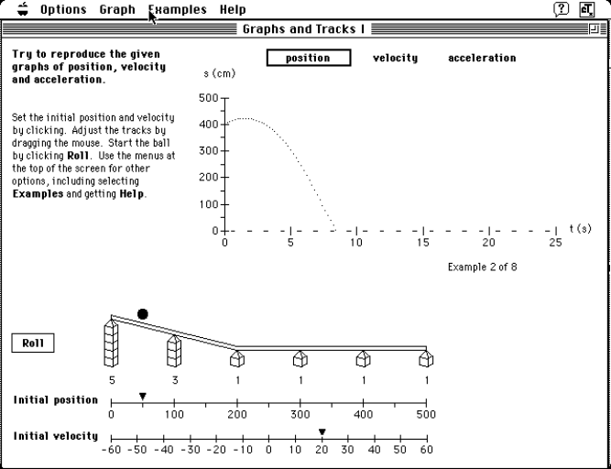
Figure 1. The GRAPHS & TRACKS I screen on a Macintosh.
The easiest way to learn how to use GRAPHS & TRACKS I is to complete the on-line tutorial. So let’s dive right in and start up the program.
To start GRAPHS & TRACKS,

- Find and open the GRAPHS & TRACKS folder (Macintosh) or program group (Windows)
- Double-click the GRAPHS & TRACKS I icon
- Click in the circle labeled “Your first time? Click here for instructions”
- Read and follow the instructions you are given in the on-line tutorial

The final page of the on-line tutorial contains some important information: the position of the ball, s, is measured along the track (as opposed to measuring the x and y coordinate positions of the mass). Also, the inclinations of the ramp segments are exaggerated when represented on the screen so that it is easier to compare the slope of one segment with that of another. Finally, you should keep in mind that although the program refers to the “rolling” of the ball, the physical situation simulated here is that of a point mass sliding along a frictionless surface.
Once you have completed the on-line tutorial, the program will immediately move on to Example 1.

- Using what you have learned in the on-line tutorial, adjust the track segments until the motion of the ball matches the given motion graphs. This may take a bit of trial and error.
- Once you have successfully matched the graphs, record the graphs and the track configuration on the following worksheets.
- Repeat this procedure for Examples 2-4. Note: To advance to the next example, choose Next Example under the Examples menu.

Questions
- How do you determine the initial position and speed of the ball?
- How do you determine which direction the ball will move when you click the ‘Roll’ button?
- While looking at a position versus time graph, how can you tell when the velocity changes from positive to negative?
- How does a velocity versus time graph change when the slope of the ramp is increased?

Student Worksheet for Graphs and Tracks
Example #

Name Date

To sketch the ramp: darken the post blocks, draw connecting lines, and write the number of blocks on the line below each post.
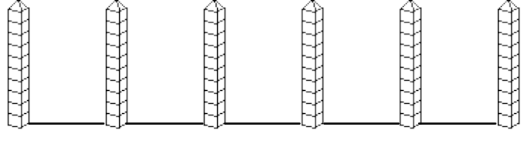
Initial position cm
Initial velocity cm/s
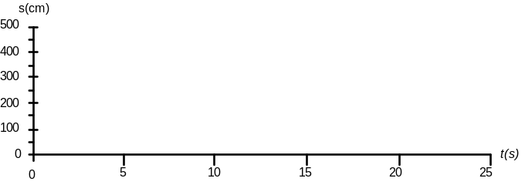
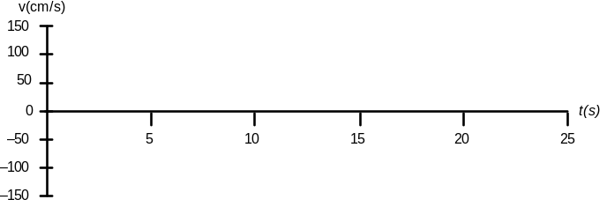
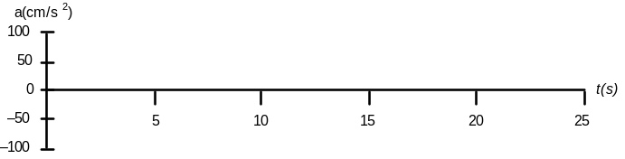

About Physics Academic Software
Editor
JOHN S. RISLEY, North Carolina State University

Editorial Board
ROBERT J. BEICHNER, North Carolina State University
DENIS DONNELLY, Siena College
ROBERT EHRLICH, George Mason University
ROBERT FAIRCHILD, Nebraska Wesleyan University
ROBERT G. FULLER, University of Nebraska
JOHN GASTINEAU, Morgantown, WV
GRAHAM OBEREM, California State University at San Marcos
E. F. REDISH, University of Maryland
J. C. SPROTT, University of Wisconsin-Madison
EDWIN TAYLOR, Massachusetts Institute of Technology
JACK M. WILSON, Rensselaer Polytechnic Institute
DEAN ZOLLMAN, Kansas State University

Physics Academic Software is a project of the American Institute of Physics, in cooperation with the American Physical Society and the American Association of Physics Teachers. Physics Academic Software reviews, selects, and publishes high-quality software suitable for use in undergraduate or graduate training in physics.

Physics Academic Software invites authors of software for teaching, laboratory, or research activities in physics to submit their software packages to the editor for review.
submitting software
Acceptance of software for publication depends on the quality of the program, completeness of the documentation, ease of use, clarity of screen displays, strength of instructional design, logic of presentation, accuracy of numerical algorithms, and effectiveness for education or research. Prospective authors should contact the editor at the address below for advice, stylistic conventions, and submission package requirements.
Authors of published software receive royalties. A licensing agreement with Physics Academic Software is required.

Submissions are reviewed by the editor, his staff, external peer referees through blind reviews, and the PAS editorial Board.
peer review

Prof. John S. Risley, Editor
mailing address
Physics Academic Software
Department of Physics
North Carolina State University
Raleigh, NC 27695–8202
Published software packages, multiple-copy license agreements, and a free catalog can be ordered from
orders

Physics Academic Software
940 Main Campus Drive
Raleigh, NC 27606

Tel. (800) 955-8275 or (919) 829-8181
Fax: (919) 829-1516
E-mail: pas@aip.org
Web: www.aip.org/pas/

Multiple-Copy License Order Form
As a registered owner of a single-copy license of this program, you can also purchase one or more Multiple-Copy Licenses. Each Multiple-Copy License authorizes you to use up to ten copies of this program. An authorized copy of this program is required for each computer operating the program simultaneously, whether the computer stands alone, uses a hard disk, or is on a network.
Mail order form and payment to:

Physics Academic Software
940 Main Campus Drive, Suite 210
Raleigh, NC
27606

Tel. (800) 955-8275 or (919) 829-8181

Fax (919) 829-1516

E-mail: pas@aip.org

Web:
www.aip.org/pas
To order one or more Multiple-Copy Licenses of this program, please contact Physics Academic Software for current pricing information, then make a photocopy of this page, fill it out, and send it, along with your payment, to the address at the left. Please allow 4 to 5 weeks for delivery.

I wish to purchase Multiple-Copy Licenses for the
software program:

Version at a total cost of $
Name
Address

City State Zip
Telephone
- Enclosed is my check payable to PAS
- Charge my credit card (circle one): VISA MC AMEX
Number Exp. Date
Signature
- P.O. number (institutions only)

Index

Archival copy vii
Assistance, technical ix
Assumptions 14
Authorized copy vii, 27

CHKMOUSE.EXE 18
Coprocessor vii
Copy
archival vii
authorized vii, 27
Copying GRAPHS & TRACKS vii-viii
cT
executor 2.01 17, 18
information 19
CT.PRF 17
CT201 viii
CTEXEC.EXE 17
CTX.EXE 17, 18

Directories viii-ix, 17-19

Exercises 21
EXTRACT.EXE 17, 18

Font requirements 19

GRAPHS & TRACKS
assistance ix
assumptions 14
copies
archival (backup) vii
multiple-copy license vii, 27
single-copy license vii
cT Executor 17, 18, 19
directories
CT201 viii, 17, 18, 19
GRPHTRCK viii,
files
Macintosh 18, 19
PC 17, 18
hardware requirements vii
installation viii
starting viii
terminology viii
GRPHTRCK viii
GT.DAT 18, 19
GT1.BAT 17
GT1.CTB 17
gt10, gt12 19
GT2.BAT 17
GT2.CTB 18

Hard disk vii
Hardware requirements vii
Help facilities 13, 14

INSTALL.COM 17, 18
Installation viii, 17
Installer 17, 18, 19

Kinematics 13

License
multiple-copy vii, 27
single copy vii

Math coprocessor vii
Memory requirements vii, 17
Motion detector 13
Multiple-copy license vii, 27

One-dimensional kinematics 13, 14

Part I—From Graphs to Motion 1-6
acceleration graphs 3
add an example 2
clear graph 5
custom example 3
dashed curve 3
delete saved experiments 3
example graphs 3
examples menu 2
free exploration 2, 5
give help once 5
goal graphs 3, 6, 14
graph menu 4, 5
gt.dat 3
help menu 5
hide help 6
initial
conditions 6, 14
position 4, 6
velocity 5, 6
instructions 2
leave help on 5
next example 2
options menu 1, 2, 5-6
pick an example 2, 3
position graphs 3
post heights 5
previous example 2
roll
ball 4
button 4
save current experiment 2
skip instructions 2
stop button 4
tracks, adjusting 5
velocity graphs 3
Part II--From Motion to Graphs 6-11
acceleration graphs 9, 10
analysis of graphs 9, 10, 11
clip menu 9
clip/restore icon 9
continuity
of slope 14
of values 14
delete
all segments 8
menu 8
drawing graphs 6, 7
examples menu 9
feedback 9, 11
help 10, 11
instructions 6, 7
next example, 9
options menu 6
pick an example 10
position graphs 10
previous example 10
question-mark icon 9–11
restore parabola 9
roll button 10
segments
clipping 9
creating 6, 7
deleting 8, 9
editing 7, 8
free-hand curve 8
joining 9
restoring 9
skip instructions 6
starting 6
velocity graphs 10
PASDRVR.EXE 18
Physics Academic Software, about 25
PSDRVR.MNU 18

Read Me 19
README.TXT 18
Requirements
font 18, 19
hardware vii
memory vii, 17
software 17, 19
system vii, 17, 19

Single-copy license vii
Software requirements 17, 19
START.BAT 18
Starting GRAPHS & TRACKS viii
Support, technical ix
System requirements vii, 17, 19

Technical support ix
Terminology viii
Tutorial 21

Worksheet 23

XMSEMS.OFF 18

*.FPC 17

END-USER LICENSE AGREEMENT AND LIMITED WARRANTY
RETAIN THIS COPY FOR YOUR FILES

This Software is licensed by Physics Academic Software Publishing Organization (PASPO) (Licensor) under a contract between it and the Author of the software. The software is protected by copyright, trademark, trade secret and other laws. It is LICENSED TO YOU, NOT SOLD and the terms of that license are as follows.

PLEASE READ THIS AGREEMENT CAREFULLY.

IF YOU DO NOT AGREE TO ACCEPT THE TERMS OF THIS AGREEMENT, PLEASE RETURN THE SOFTWARE AND ASSOCIATED MANUALS TO THE PLACE OF PURCHASE WITHOUT BREAKING THE SEAL ON THE ENVELOPE CONTAINING THE SOFTWARE.

IF YOU DO AGREE TO THE TERMS OF THIS AGREEMENT, PLEASE FILL OUT AND MAIL THE REGISTRATION CARD ACCOMPANYING THIS AGREEMENT. BY BREAKING THE SEAL, YOU AGREE TO BE BOUND BY THE TERMS OF THIS AGREEMENT, WHETHER OR NOT YOU SIGN AND RETURN THE REGISTRATION CARD.

In exchange for your payment of the license fee, PASPO, pursuant to a license-contract with the Author, hereby grants to you a non-assignable, non-exclusive sublicense to use this magnetic media and any associated manuals or other documentation (collectively, the “Software”) under the following terms and conditions:

1. You may use the copy of the Software provided to you on no more than one personal computer or terminal at a time, unless the documentation accompanying the Software specifically authorizes site-licensing or the use of the Software in connection with a network or multi-terminal arrangement. You may make one archival, or “backup” copy of the Software for your own personal use.

2. You may not use or reproduce the Software except as expressly provided in this Agreement. You agree that the Software contains valuable, unpublished information developed or acquired by Licensor or Author at great expense and you agree to take reasonable steps to protect the Software from theft or use contrary to this Agreement. You may not modify or translate the Software, and may not decompile or in any way derive from the Software any source code (unless the Software has been distributed to you in source code form).

3. You may not transfer or otherwise distribute to any other person the Software except as provided in this Agreement. You may transfer your rights in this Software to another user so long as the user agrees to be bound by the terms of this license; the user may do this by sending a copy of this license, bearing the user’s signature, to the Licensor. If you transfer the Software you must destroy any copies of the Software and documentation which you may have made.

4. Your payment of the license fee does not entitle you to any support or maintenance of the Software, or to any upgrades or revisions.

The Licensor warrants the magnetic media on which the Software is furnished to be free from defects for a period of 90 days after receipt by the user.

EXCEPT FOR THE LIMITED WARRANTY ON THE MEDIA, THE LICENSED SOFTWARE IS PROVIDED AS IS WITHOUT WARRANTY OF ANY KIND, EITHER EXPRESSED OR IMPLIED. THERE ARE NO IMPLIED WARRANTIES OF MERCHANTABILITY OR FITNESS FOR A PARTICULAR PURPOSE. THE ENTIRE RISK AS TO THE QUALITY AND PERFORMANCE OF THE LICENSED SOFTWARE IS WITH YOU. NEITHER THE AUTHOR, NOR THE LICENSOR, SHALL HAVE ANY LIABILITY FOR ANY KIND OF DAMAGES, WHETHER DIRECT, INDIRECT, INCIDENTAL OR CONSEQUENTIAL ARISING OUT OF THE USE OR PERFORMANCE OF THE LICENSED SOFTWARE OR DOCUMENTATION OR ANY SERVICES PROVIDED IN CONNECTION THEREWITH. (Some states do not allow the exclusion or limitation of incidental or consequential damages, so this limitation might not apply to you.)

Licensor’s entire liability and exclusive remedy shall be the replacement of any magnetic media which fails to meet the Licensor’s “Limited Warranty.” In the event that, notwithstanding this disclaimer, liability is found for some defect in the Software, whether based on contract, negligence, strict liability in tort, breach of warranty or any other legal theory of liability whatsoever, the amount of any such liability shall not exceed the license fee paid by you for your license for the Software.

1. You acknowledge that you have read this Agreement, that you understand it, and that you agree to be bound by its terms. You further agree that this agreement is the complete and exclusive statement of agreement between the parties, and supersedes any other agreements, oral or written, between the parties concerning the Software. It may not be modified or altered in any way, including by purchase order, advertising or other representation, except in a written instrument signed by both you and an authorized representative of the Licensor.

2. You acknowledge that you do not own the Software and that nothing in this Agreement shall be deemed to give you ownership rights to any of the tangible or intangible property that is part of the Software.

3. The agreement is governed by the laws of the State of North Carolina and any controversy arising under it shall be decided in accordance with the substantive laws of the State of North Carolina.

4. The failure of either party to enforce, in any one or more instances, any of the terms or conditions of the agreement shall not be construed as a waiver of the future performance of any such term or condition. If any term of this agreement is held illegal or unenforceable by any court of competent jurisdiction, such term shall be considered inoperable only to the extent of such illegality or unenforceability, and such holding shall not impair the validity or enforceability of the remaining terms of this agreement. The parties agree to replace any such illegal or unenforceable provision with a new provision which has the most nearly similar permissible economic or other effect.

5. The license granted pursuant to this Agreement is effective until terminated. The license will automatically terminate if you fail to comply with any term or restriction of this Agreement. In addition, Licensor may terminate this license in the event of any legal action or threat of legal action involving trademark, copyright, patent, trade secrets, unfair competition, or any other similar claim, or for any other reason deemed sufficient to Licensor. Upon termination you agree to return to Licensor all Software provided to you pursuant to this Agreement, and any copies of all or any part of that Software that have been made by you, and to destroy any other computer programs, documentation, or other written material containing any portion of the Software.

6. The terms of this license will apply to all upgrades, enhancements, new versions and new releases, unless the parties agree, in writing, to the contrary.

Physics Academic Software Publishing Organization
940 Main Campus Drive, Suite 210
Raleigh, NC 27606-5212
Licensor

